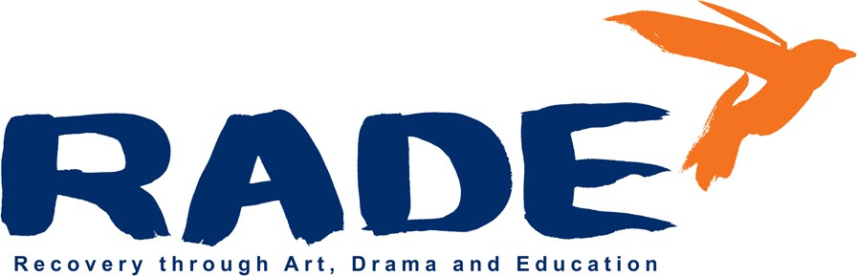
OLV Building Cathedral View Court Off New St Dublin 8
Tel: 01 454 8733 Email: rade@iolfree.ie

RADE Recovery Through Art Drama and Education
Job Opportunity

Community Employment Supervisor

RADE is an addiction service based in Dublin 8 established in 2004. Our mission is to engage people who wish to address substance and alcohol dependency through the arts. Our vision is that creativity is open to everyone.

Job Description

Title: Community Employment Supervisor (CE) - Training and Rehabilitation Location: RADE, OLV building, Cathedral View Court, Off New St, Dublin 8 Contract type: Full Time - 39 hours per week (excluding lunch) Monday to Friday Reporting to: Project Director
Purpose: To ensure the effective and efficient management and co-ordination of the human, financial and material resources of the CE scheme and report to the Sponsoring Committee on its implementation. A core aspect of the role is to provide a framework for the rehabilitation and recovery of CE participants and to coach and support them towards gaining skills, competencies and qualifications in preparation for employment.

Closing Date & Time: 5pm, Monday 1st December 2025

Training and Development
- Establish individual participant’s and support worker learner needs as part of the Individual Learner Plan process, working closely with RADE key-working team
- Source and co-ordinate cost effective training and development opportunities in line with procurement guidelines, showing an understanding of the range of programmes and courses available to unemployed and vulnerable adults

- Ensure access to recognised qualifications for participants including Major Awards on the National Framework of Qualifications (NFQ) or industry related standards
- Prepare an Individual Learning Plan (ILP) for each participant and upload to Welfare Partners (Department of Social Protection portal)
- Update and manage records of all participants
- Prepare contracts for trainers
- Conduct holistic assessments and inductions of all programme applicants
- Manage a caseload of participants in addiction recovery. Provide recovery and advocacy support, liaising with referring agencies and services and overseeing work placements.
- Make regular contact with other agencies involved in participant’s care and treatment in a care and case management capacity.
- Scheduling and attendance at RADE’s weekly Participant Progression meetings
- Facilitate weekly relapse prevention and check-in sessions
- Co-ordinate and supervise the arts training programme

Administration
- Manage effective time-keeping record system for participants
- Liaise with local DSP department office as required
- Register new positions with Jobs Ireland
- Assist with work on RADE policies
- Assist with preparation for annual DSP roll over and three-year DSP renewal
- Assist with Annual Report
- Manage and oversee completion of all DSP related forms to enrol new participants
- Ensure the CE scheme is compliant with programme and training monitoring requirements as detailed in the CE Operating Procedures.
- Co-operate with the DSP Departmental monitoring visits
- Develop, and maintain RADE database as required
- Assist with any other duties as required by the project

Human Resources
- Recruit and manage team of CE support workers
- Maintain supervisor and participant time sheets
- Co-ordinate the recruitment of CE applicants in accordance with CE recruitment and referral processes

- Plan and co-ordinate work schedules and ensure annual contracts of employment are in place for all participants
- Implement job search activities with participants
- Liaise with employers to promote progression to work and other support organisations as needed
- Maintain an up-to-date database of employers and record of engagement
- Develop an exit plan with each participant
- Follow-up and report on participants for up to 4 months on exit from CE
- Manage staff resources as required
- Report regularly to the RADE Board (CE Sponsoring Committee)

Community Employment
- Provide a safe and healthy environment for participants – both in terms of facilities and work practices
- Supervise, schedule and manage participants
- Engage in training and development opportunities provided as required for the post
- Carry out any other functions relevant to the position of CE Supervisor as indicated by Sponsor
- Ensure RADE governance and work polices are updated
- Update and maintain staff and participant handbooks
- Provide supervisory cover when needed

Requirements for the position:
- Work Experience - Minimum of 3 year’s experience in a supervisory/ management capacity. Also experience in the field of addiction and administration/training or other relevant positions
- Qualifications Major Award at 3rd level or minimum NFQ Level 6, preferably in relevant area
- Knowledge of Post - A solid understanding of the role of CE Supervisor as it pertains to project management and programme delivery
- Interpersonal Skills Effective communication skills, competent report writing, experience of working with vulnerable adults
- Office Skills Excellent administration, budgeting and computer literacy skills including Microsoft Excel and Word

Desirable experience:

- Teaching of holistic practices, e.g. yoga, meditation, Tai-chi
- Art class facilitation and presentation skills
- Experience of publication, design and layout
- Understanding of IT maintenance
- Knowledge of addiction issues and experience working with service users towards rehabilitation
- Website and social media maintenance

Remuneration:
Salary commences at point 1 of the Supervisor Community Employment Salary Scale at a weekly gross wage of €728.92. A CE Supervisor who moves directly from one CE scheme to another without taking leave will retain their salary scale and associated wage level.
This position is subject to garda vetting.

To Apply: Please submit a covering letter and curriculum vitae outlining your suitability
By Email: raderecruit@gmail.com quoting Recruitment RADE in the subject line
Queries: Please address any queries you may have to raderecruit@gmail.com
Closing Date & Time: 5pm, Monday 1st December 2025
http://www.rade.ie/

